CHAPTER 3

METHODOLOGY

This chapter describes about methodology used for this project. The chapter will cover overview of methodology, waterfall methodology, and phases of waterfall. The objectives are to fulfil the project requirement and follow every stage based on the chosen System Development Life Cycle (SDLC) model for system development. For this chapter, the chosen model is Waterfall Method.
3.1 Overview of Methodology
Methodology is a guideline to accomplish the task or undertake a study. In general, to completing the task, the guidelines and rules have to be obtained and follow based on the specific subject through process of learning and understanding. There are many ways to accomplish the necessary tasks. SDLC gives an outline in development process from requirement gathering to implementation where SDLC plays an important role in software development. SDLC has many lifecycles within the framework with different advantages and disadvantages which giving the uniqueness toward different projects.
3.2 Waterfall Methodology for Centralized Web-Based for Stress Induction Methods
The waterfall model is the classical model for the SDLC used to create sequential and linear systems. Therefore, such requirements are not liable to frequent change during development. Thus, the structured and documentation-driven Waterfall model gives clarity, traceability, and ensures orderly progression throughout development (Pressman, Maxim, 2020). The output of one phase serves as the input for the subsequent phases in this paradigm, which are divided into the next action. Every stage needs to be finished before the start of the subsequent phase, and the stages do not overlap. This design comprises consisting of three stages: Requirement Gathering, System Design and Implementation.

- Add more sentences
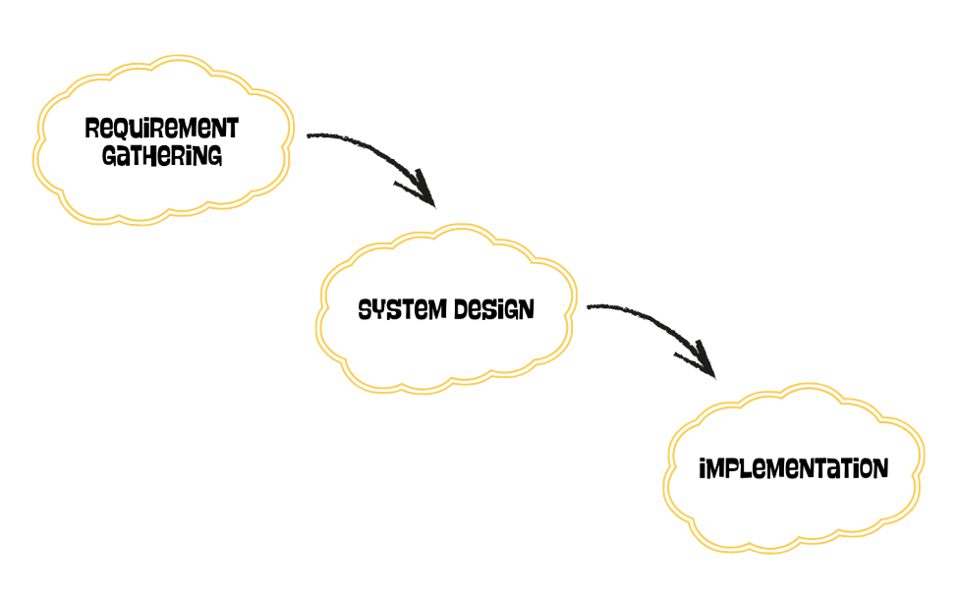
Figure 3.1 Implemented Waterfall Model for Centralized Web-Based System for Stress Induction Methods
3.3 Phases
The three phases are requirements gathering, system design, and implementation. Each one contains a set of tasks that must be finished before moving on to the next phase in order to achieve the goals.

\\\\\\\\\\\\\\\\\\\\\\\\\\\\\\\\\\\\\\\\empty\\\\\\\\\\\\\\\\\\\\\\\\\\\\\\\\\\\
Phase | Activities | Deliverables | Objectives
Requirement Gathering and Planning | a) Conduct research to identify user needs and system requirement  b) Create required requirements schematics  c) Define the project scope and goal | a) Requirements Data  b) Diagram of requirements:  i) Use case diagram  ii) Domain class diagram  iii) Activity Diagram  iv) Sequence Diagram  c) Create the System Requirement Specification | To gather and analyze the requirement of the Centralized Web-Based System for Stress Induction Methods
System Design | a) Design the user interface  b) Design system architecture and database schema  c) Document all the system design | a) Create storyboard for the flow of the system  b) Design diagram:  i) Design class diagram  ii) Detail Class diagram  iii) Entity Relationship Diagram  iv) Multi-layer Sequence Diagram  c) Software Design Documentation (SDD) | To design the web-based system for Stress Induction Methods
Implementation | a) Develop the database  b) Connect interface and database  c) Develop the modules | a) Create database using MariaDB  b) Functional system integration  c) Complete system | To develop a web-based system for Stress Induction Methods
Table 3.1 The Project framework using SDLC approach

3.3.1 Phase 1: Requirement Gathering and Analysis
The initial stage of the methodology is Requirement Analysis. This stage emphasizes analysing the requirements for the system from various literature publications. The project is analysed from different article and journal that related to web-based system and stress related.
Literature reviews are used to get all functional and non-functional requirement. The functional requirements are such the system tasks, system functionality, and how the system will work for the user. The non-functional requirements identify the usability, scalability, and reliability of the system.
After the analysis and identifying the requirement, system modelling diagram will be generating use to represent the system functionality. The system modelling such as use case diagram, activity diagram, sequence diagram, and domain class diagram.
3.3.2 Phase 2: System Design
Second phase is design phase, where this phase will design based on the system specification and requirement. Designing Centralized Web-Based System for Stress Induction Method is this phase main objective. This stage requires designing the user interface based on the storyboard for the system flow. System interface will be developed using Visual Studio code. Draw.io will be used to draw a diagram such as Design Class Diagram. The last step is to document full system design including the software.
3.3.3 Phase 3: Implementation
The third phase which is implementation phase is where the system is developed using a tool and programming language. It is the costliest and time-consuming development process which the goal is to build this project.
The objective of this phase is to build the system. The proposed system are build using PHP programming by using Visual Studio Code as tools for the website development. The system using MariaDB as database. The hardware and software use to develop the system are shown in Table 3.2 and 3.3.
Table 3.2 Hardware Specifications
No. | Hardware | Description
1. | Laptop | Brand: Asus  Processor: AMD Ryzen 5  Installed Memory (RAM): 12 GB  OS Name: Windows 11
2. | Smartphone | Brand: Google  Model: Pixel 6 Pro

The laptop used on making the report and develop the system is a good piece of hardware. It has enough RAM and well-known processor to build and run the system including the latest operating system, Windows 11, which supports almost all development software. The next piece of hardware is smartphone, which used as a test for the web-based system to use in smartphone. The system is enough to use internet and other recording method.
Table 3.3 Software Specification
Software | Specification
Software Platform | Visual Studio Code
Database | MariaDB
Design Tools | Draw.io
Documentation | Microsoft Word
Presentation | Canva
Browser | Brave

All software used to create the system is described in the software specifications.
3.5 Summary
This chapter ends with a discussion about how the project under development would be accomplished. The waterfall method would be used as the method for completing a project. The aim and method utilized for a project are apt for a waterfall method. The three stages for this project, which are gathering requirements, designing, and implementation.

